Program 3: Working with Selenium: Maven Project To Connect To Web Servers Using Selenium Dependency
1.Sauce.demo webpage
Step 1: create a maven project on terminal by typing the command mvn archetype:generate -DgroupId=com.example -DartifactId=MyMavenSeleniumApp01 -DarchetypeArtifactiId=maven-archetype-quickstart -DinteractiveMode=false
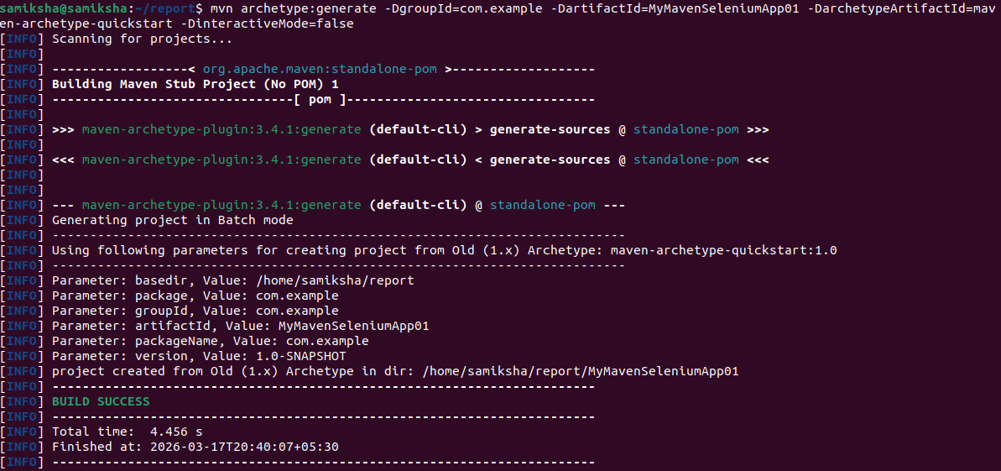

Step 2: Before we connect to web servers we need to have chrome driver installed. To download chrome driver
To check the chrome version type the command google-chrome –version in the terminal
extract the version and store it in a variable CHROME_VERSION
extracts and transorms JSON data
LATEST_DRIVER=$(curl -s "https://googlechromelabs.github.io/chrome-for-testing/latest-patch-versions-per-build.json" | jq -r ".builds[\"$CHROME_VERSION\"].version")
do install curl using the command
sudo apt install curl
wget https://storage.googleapis.com/chrome-for-testing-public/$LATEST_DRIVER/linux64/chromedriver-linux64.zip

Extract and move it to /usr/local/bin/:

unzip chromedriver-linux64.zip
sudo mv chromedriver-linux64/chromedriver /usr/local/bin/chromedriver
sudo chmod +x /usr/local/bin/chromedriver
Check if ChromeDriver is installed correctly:
Step 3 : edit the pom.xml file and add the dependencies
The pom.xml has the code

<project xmlns="http://maven.apache.org/POM/4.0.0" xmlns:xsi="http://www.w3.org/2001/XMLSchema-instance"
xsi:schemaLocation="http://maven.apache.org/POM/4.0.0 http://maven.apache.org/maven-v4_0_0.xsd">
<modelVersion>4.0.0</modelVersion>
<groupId>com.example</groupId>
<artifactId>MyMavenSeleniumApp01</artifactId>
<packaging>jar</packagi<ng>
<version>1.0-SNAPSHOT</version>
<name>MyMavenSeleniumApp01</name>
<url>http://maven.apache.org</url>
<dependencies>
<dependency>
<groupId>junit</groupId>
<artifactId>junit</artifactId>
<version>3.8.1</version>
<scope>test</scope>
</dependency>
<!-- https://mvnrepository.com/artifact/org.seleniumhq.selenium/selenium-java -->
<dependency>
<groupId>org.seleniumhq.selenium</groupId>
<artifactId>selenium-java</artifactId>
<version>4.29.0</version>
</dependency>
</dependencies>
<!-- Build: Configuring plugins and build settings -->
<build>
<plugins>
<!-- Example: Maven Compiler Plugin to compile Java code -->
<plugin>
<groupId>org.apache.maven.plugins</groupId>
<artifactId>maven-compiler-plugin</artifactId>
<version>3.8.1</version>
<configuration>
<source>1.7</source>
<target>1.7</target>
</configuration>
</plugin>
<!-- Example: Maven Surefire Plugin to run tests -->
<plugin>
<groupId>org.apache.maven.plugins</groupId>
<artifactId>maven-surefire-plugin</artifactId>
<version>2.22.2</version>
</plugin>
<plugin>
<groupId>org.apache.maven.plugins</groupId>

<artifactId>maven-jar-plugin</artifactId>
<version>3.0.1</version>
<configuration>
<archive>
<manifestEntries>
<Main-Class>com.example.App</Main-Class>
</manifestEntries>
</archive>
</configuration>

</plugin>

</plugins>
</build>
</project>
Step 4: Edit the App.java
package com.example;

import org.openqa.selenium.By;
import org.openqa.selenium.WebDriver;
import org.openqa.selenium.chrome.ChromeDriver;

/**
* Hello world!
*
*/
public class App
{
public static void main( String[] args )
{
WebDriver driver=new ChromeDriver();
driver.get("https://www.saucedemo.com/");
driver.manage().window().maximize();
driver.findElement(By.id("user-name")).sendKeys("standard_user");
driver.findElement(By.id("password")).sendKeys("secret_sauce");
driver.findElement(By.id("login-button")).click();
}
}

Step 5:build and run the maven application
Type mvn clean install in the terminal
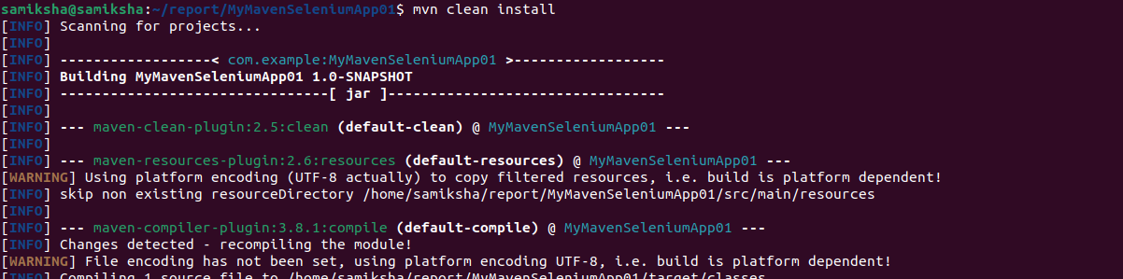
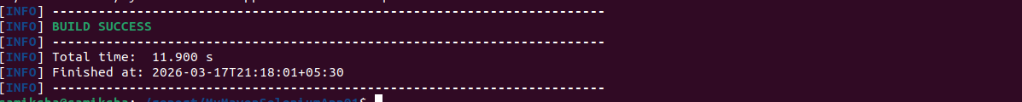

To execute type the command mvn exec:java -Dexec.mainClass="com.example.App"
it opens saucedemo.com and we can login using the credentials
